MONGO DB – CRUD Tasks

Task 1 — Student Management System
Objective
Create a MongoDB database to manage students and perform CRUD operations.
Collection Name
students
Document Structure
{
"student_id": 101,
"name": "Arun Kumar",
"department": "CSE",
"year": 3,
"skills": ["Java", "MongoDB", "Python"],
"marks": {
"dbms": 85,
"java": 90,
"python": 88
},
"active": true
}

Tasks
CREATE

1 Create database college_db
2. Insert 10 student documents

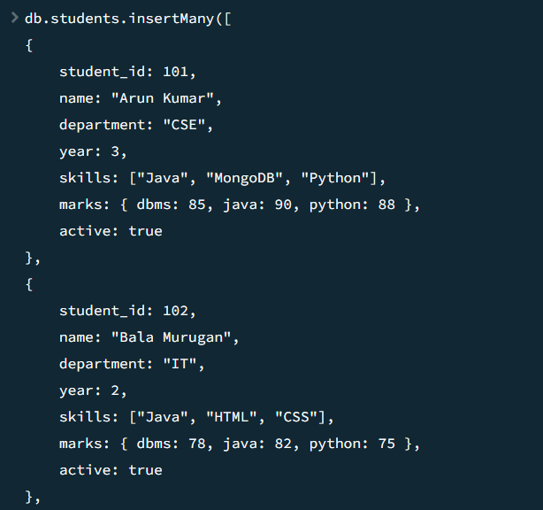

3.Insert one student with multiple skills and nested marks object
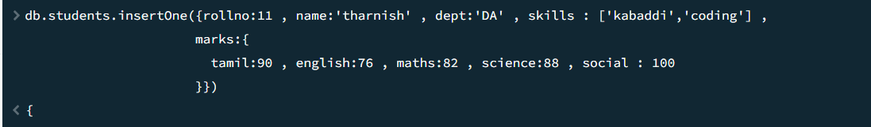
4.Insert many students at once

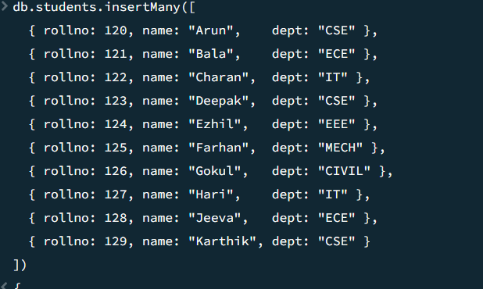

READ
- Display all students
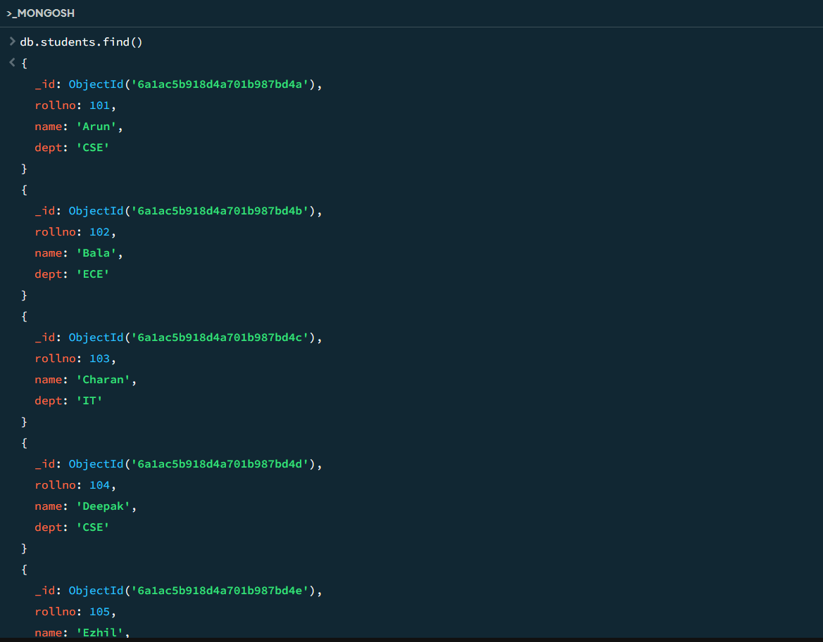

- Find students from CSE
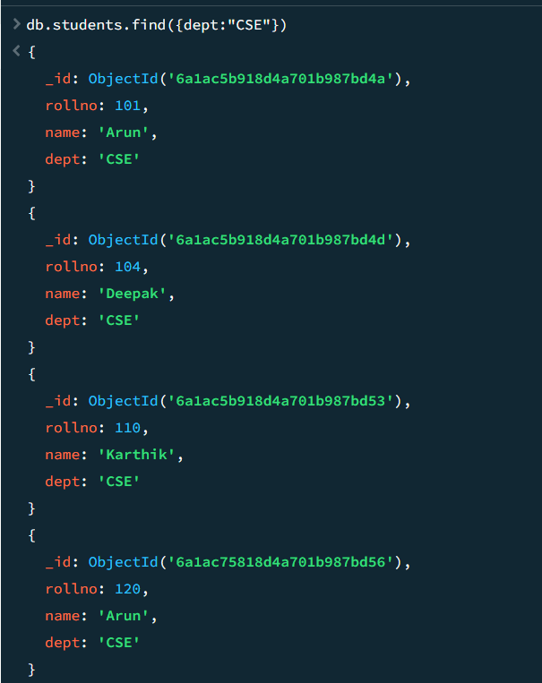
- Find students whose year is greater than 2
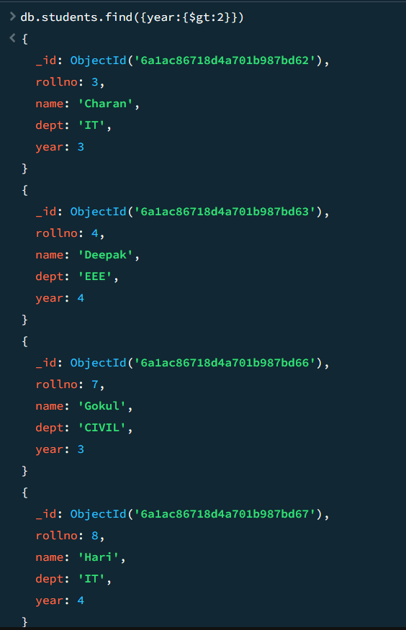
- Find students having skill MongoDB

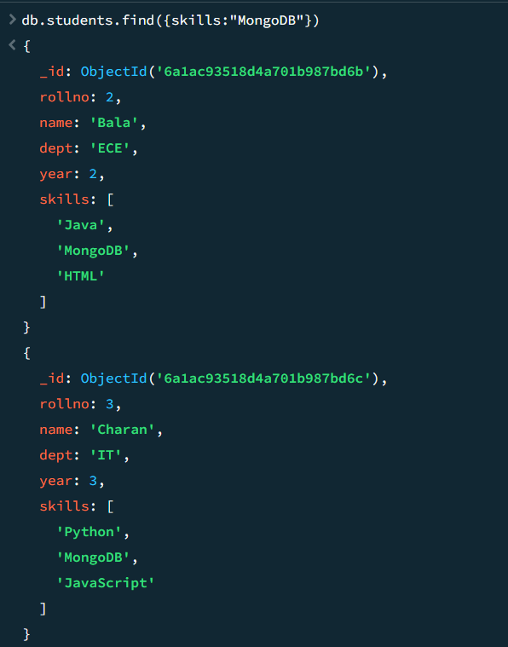

- Display only name and department
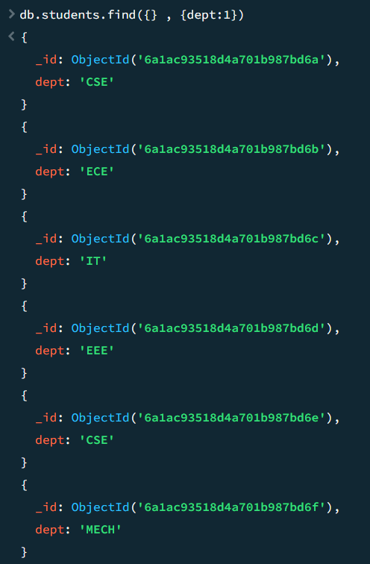
- Find students whose python mark is greater than 80
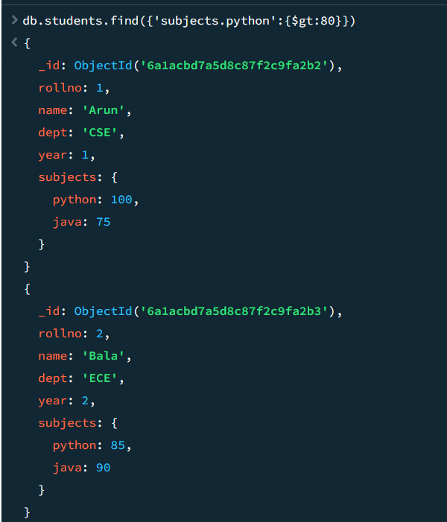

- Sort students by name ascending
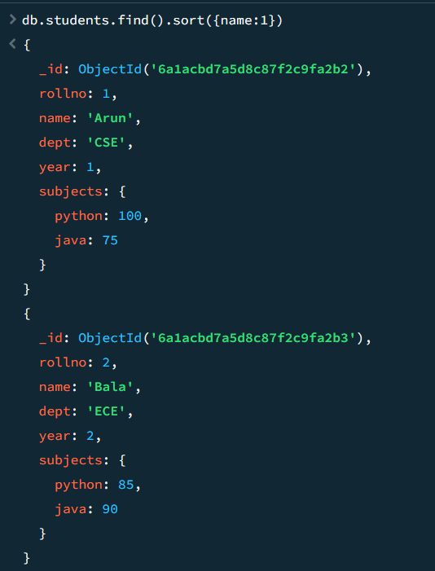
- Display top 3 students based on java mark
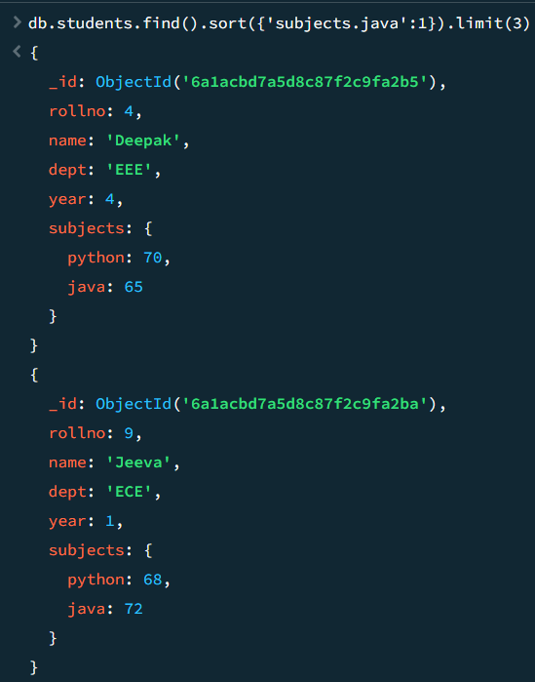

UPDATE
- Update department of a student
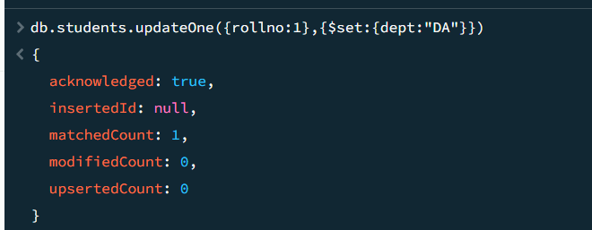
- Add new skill NodeJS
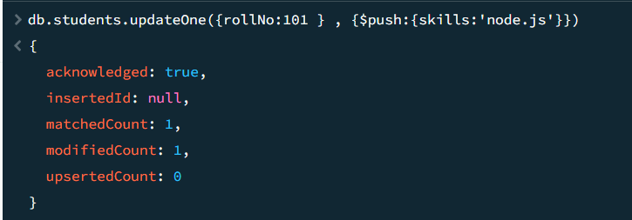
- Increase python marks by 5
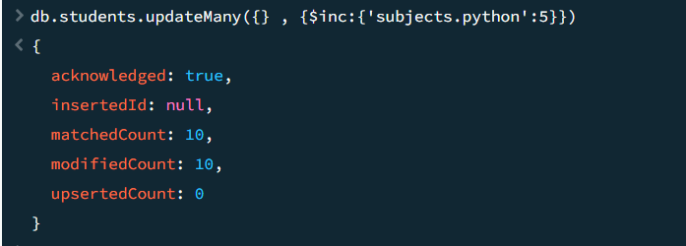

- Rename field active to status
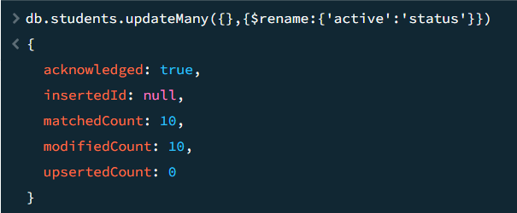
- Remove one skill from skills array
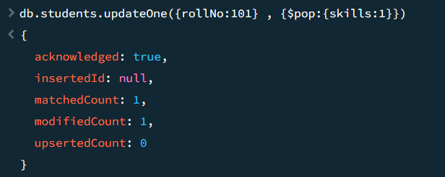
- Update multiple students of same department
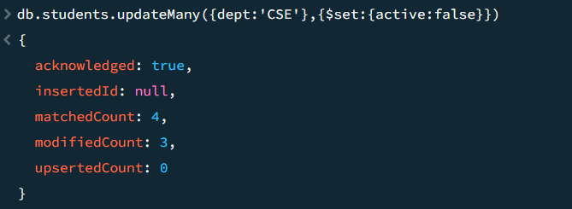

DELETE
- Delete one inactive student
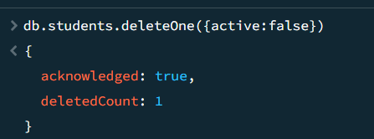
- Delete students whose year is 1
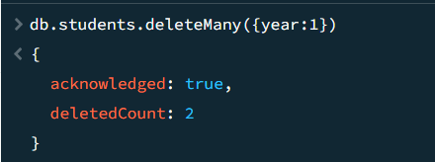
- Delete all students from a specific department
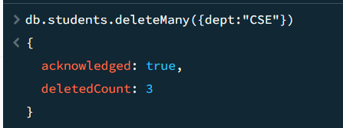

Task 2 — Online Shopping Cart
Collection Name
products
Document Structure
{
"product_id": 1001,
"product_name": "Laptop",
"category": "Electronics",
"price": 65000,
"stock": 15,
"brand": "Dell",
"ratings": [4, 5, 5, 3],
"supplier": {
"name": "ABC Traders",
"city": "Chennai"
}
}
Tasks
CREATE
- Create database shopping_db
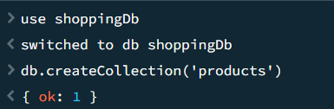
- Insert 15 product documents
- Insert products with embedded supplier details
- Insert products with array field ratings
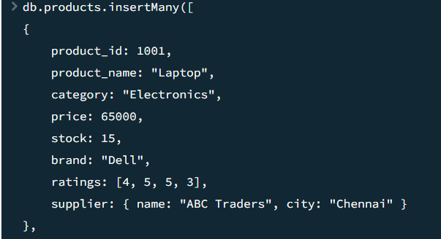

READ
- Find all electronics products
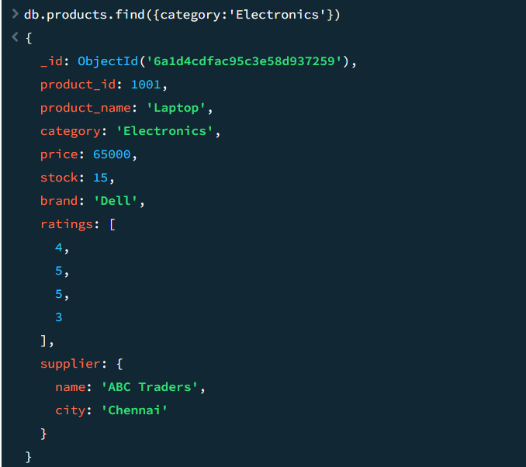
- Find products price greater than 50000
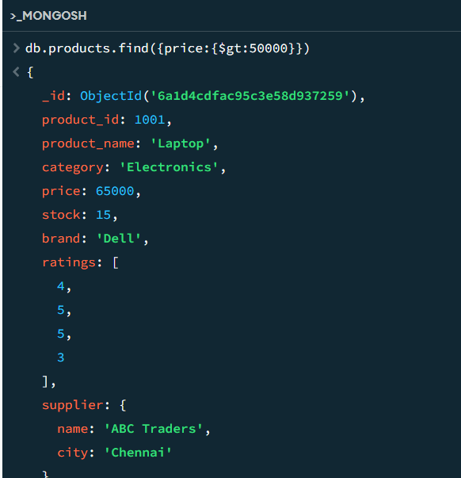
- Find products with stock less than 10
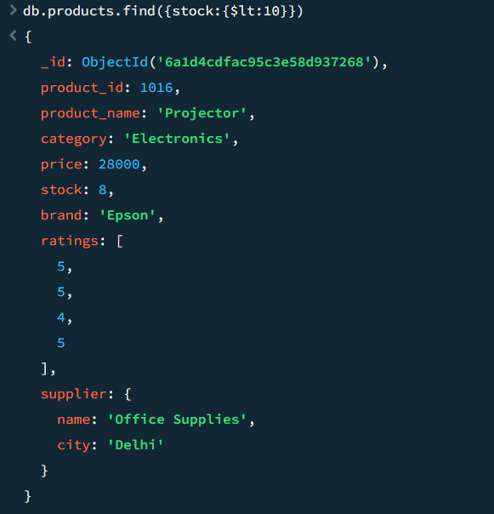
- Find products supplied from Chennai
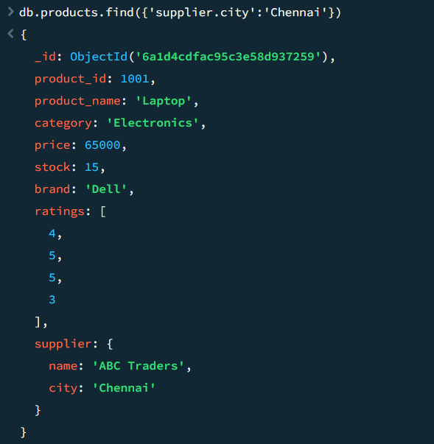

- Display only product name and price
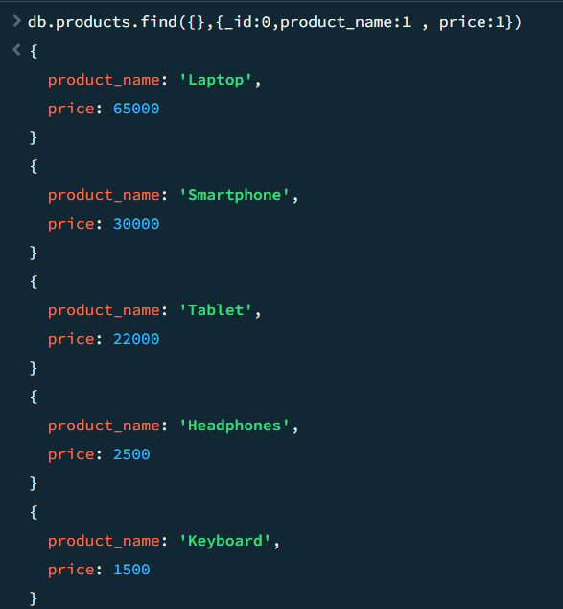
- Find products having rating 5
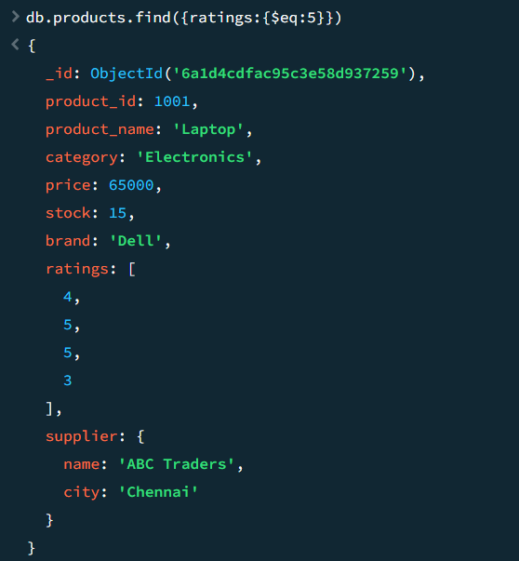
- Sort products by price descending
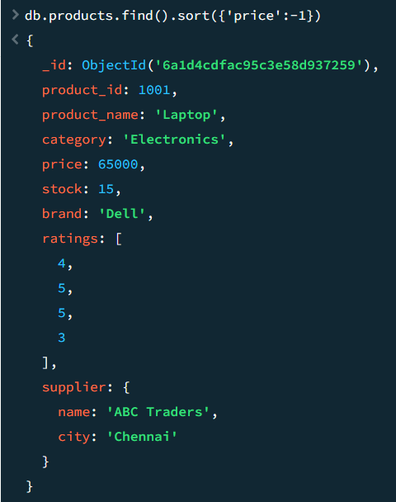
- Find top 5 costly products
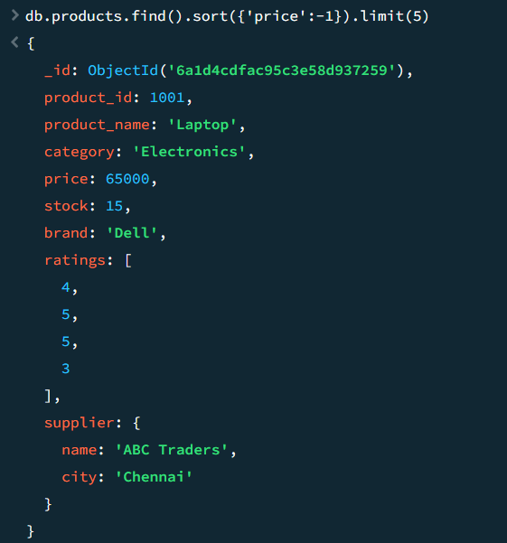

UPDATE
- Increase stock by 10
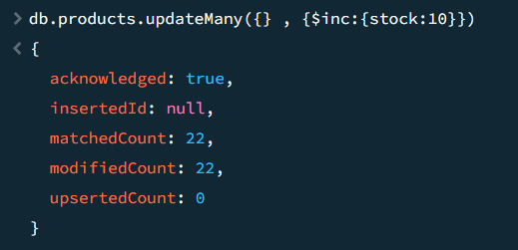
- Update supplier city
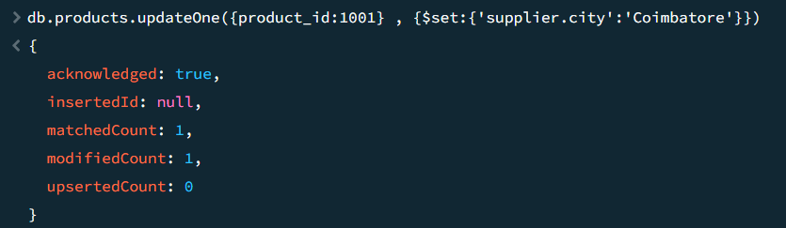
- Add new rating to ratings array
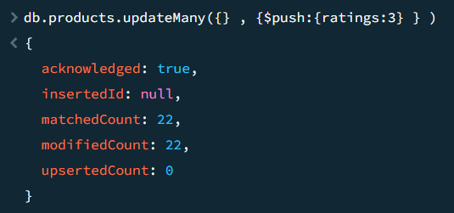

- Reduce price by 5%
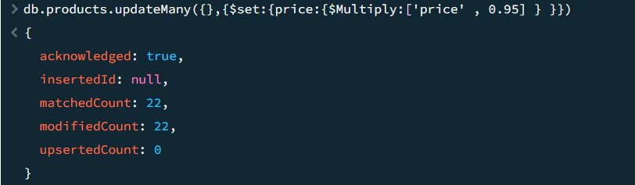
- Rename field brand to company
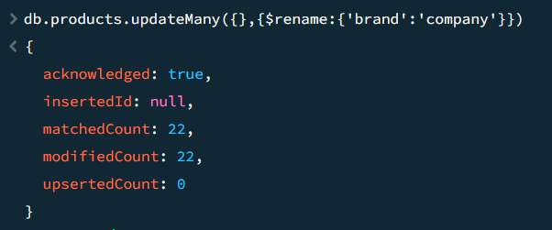
- Update multiple products category-wise
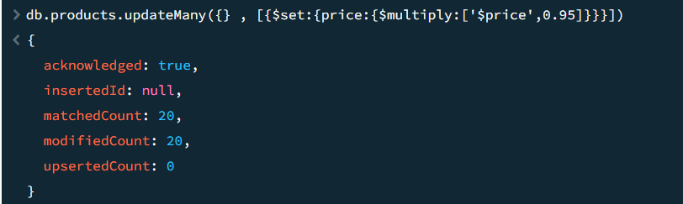

DELETE
- Delete products with zero stock
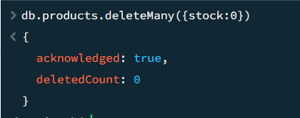
- Delete all products from a category
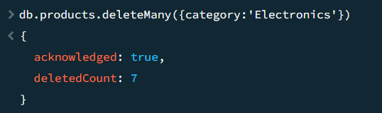
- Delete products whose price is below 1000
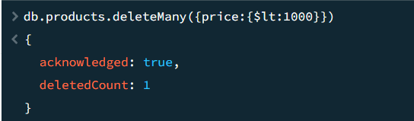

Tasks – III
CREATE
- Create database hospital_db
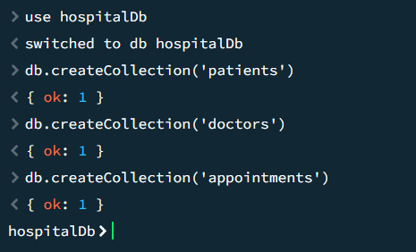
- Insert 20 patients
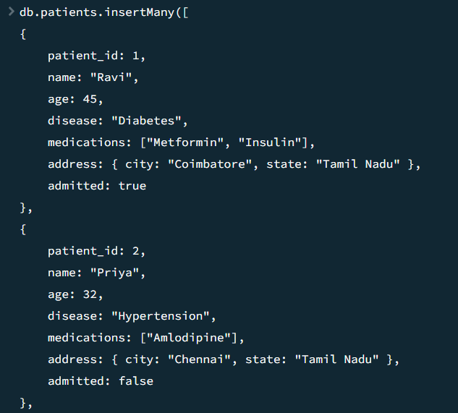

- Insert 10 doctors
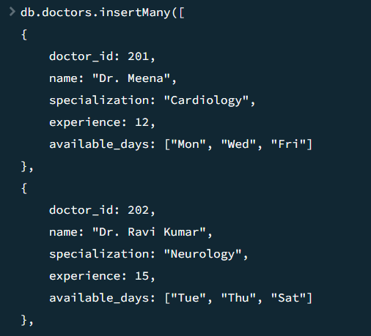
- Insert 30 appointments
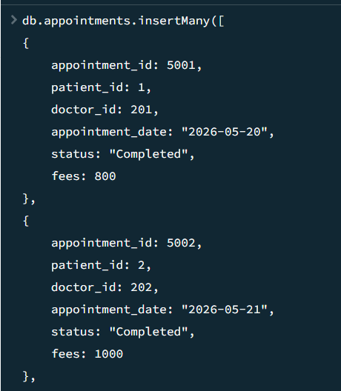

- Use nested objects and arrays properly
Used in the above Insertions

READ
- Find admitted patients
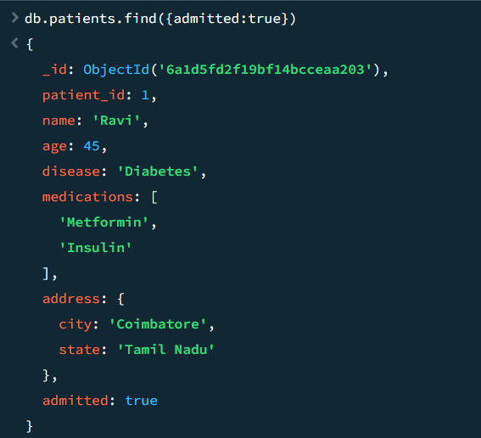
- Find doctors available on Friday
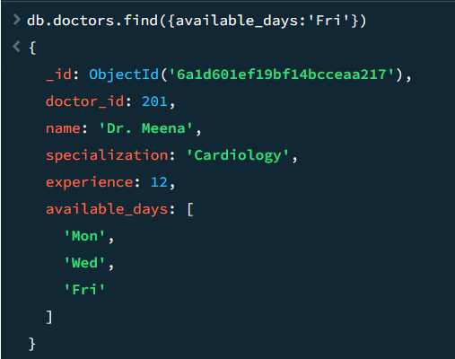

- Find appointments with fees greater than 1000
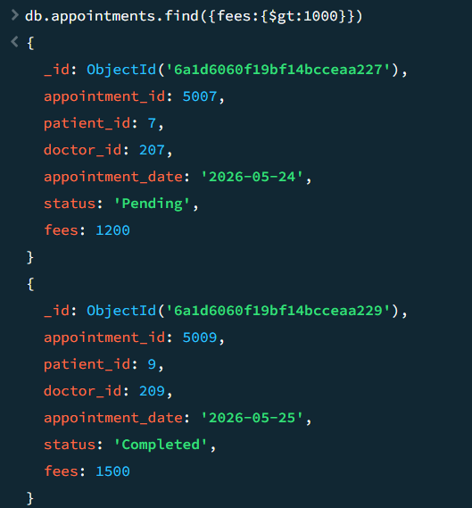
- Display patients from Tamil Nadu
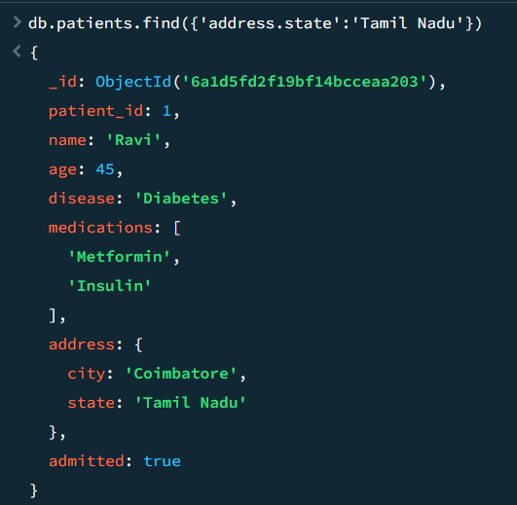

- Find patients taking Insulin
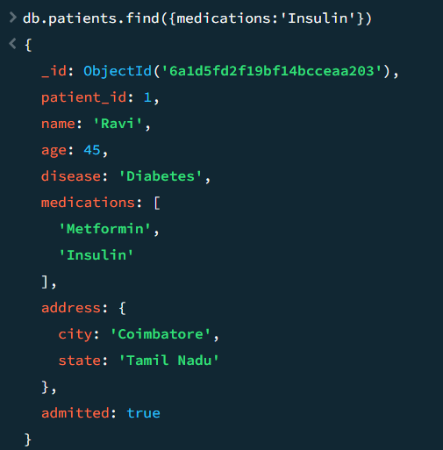
- Find completed appointments
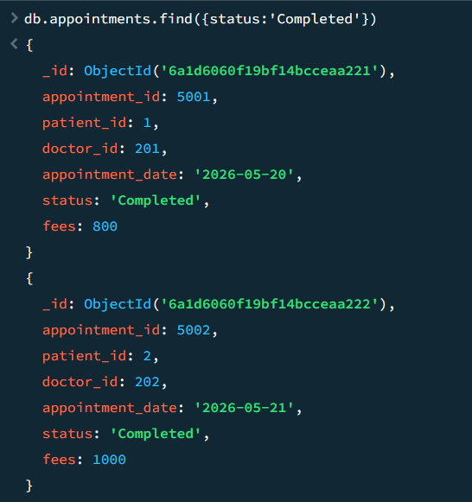

- Display appointments sorted by date
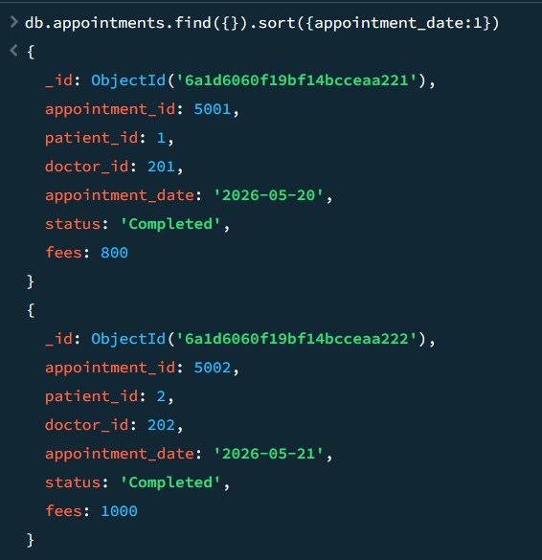
- Find doctors with more than 10 years experience
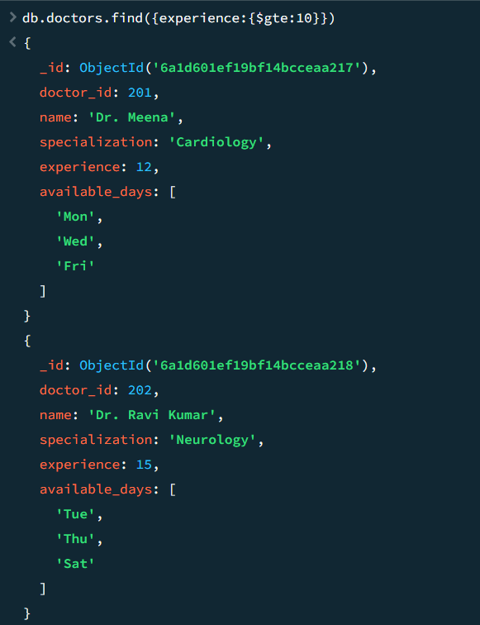

UPDATE
- Add new medication to patient
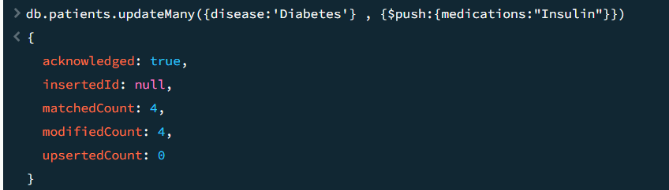
- Change appointment status
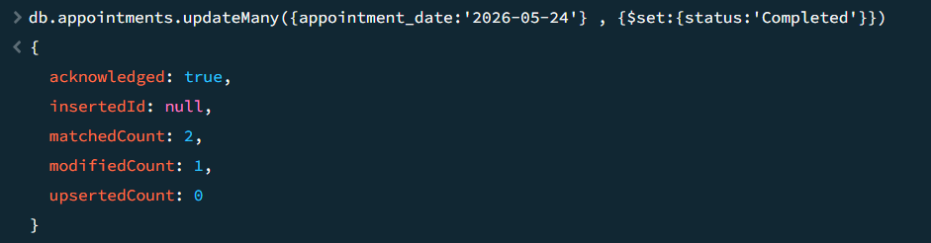
- Increase doctor experience by 1
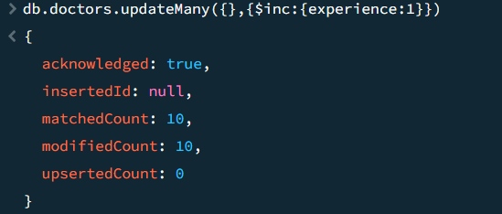
- Update all appointments fees by 10%
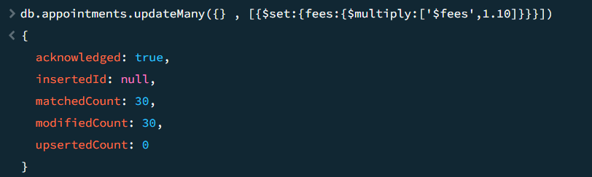
- Add available day to doctor
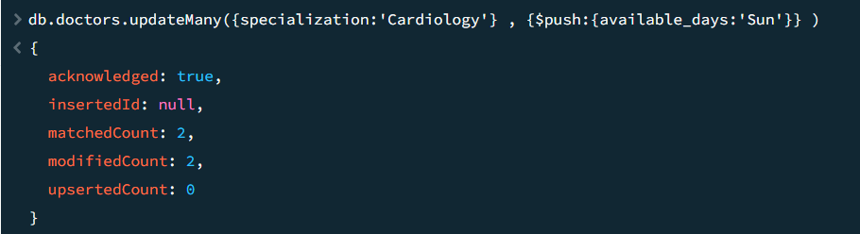
- Remove medication from patient array
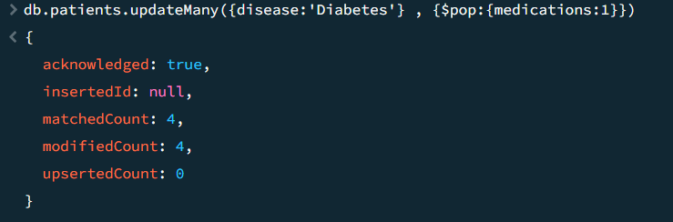
- Update embedded address city
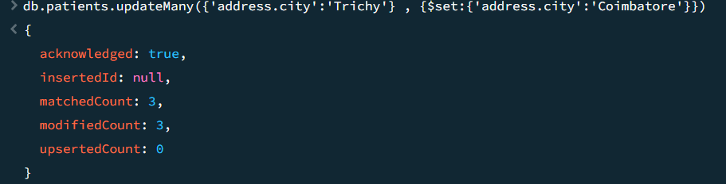

DELETE
- Delete cancelled appointments
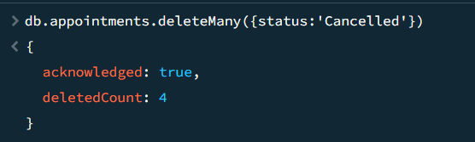
- Delete patients not admitted
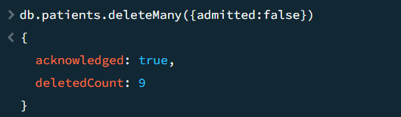
- Delete doctors with less than 2 years experience
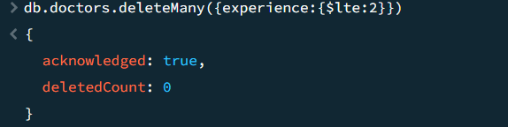

ADVANCED CRUD OPERATIONS
- Use $push, $pull, $inc, $set, $rename
push
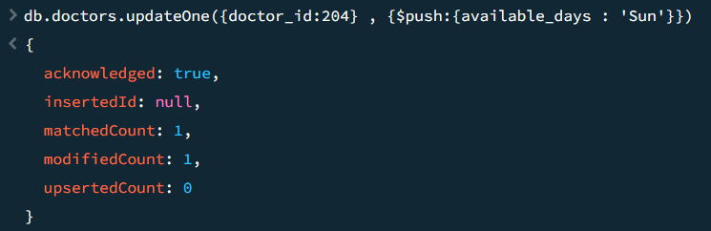
Pull
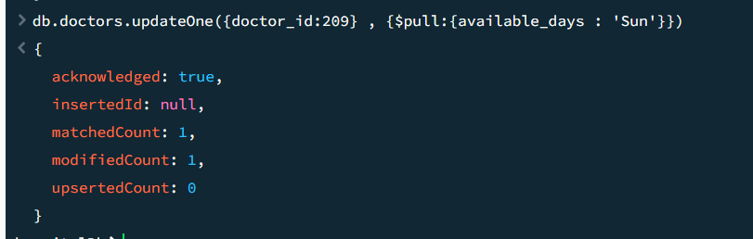
Increment
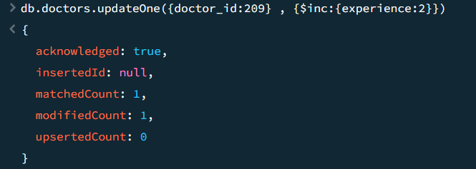

Set
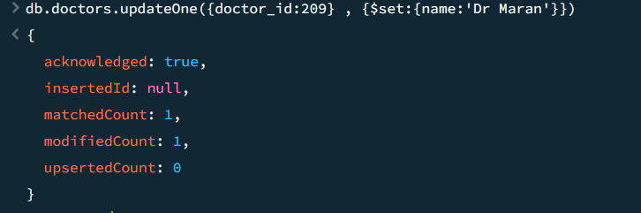

Rename
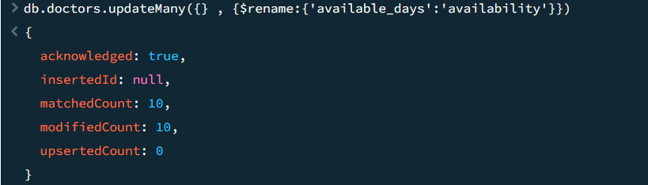

- Use projections
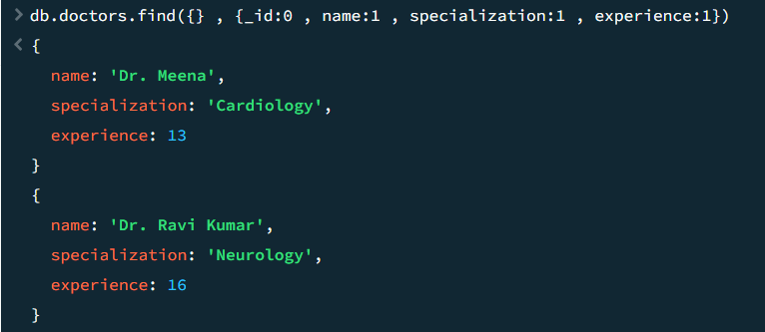

- Use sorting and limiting
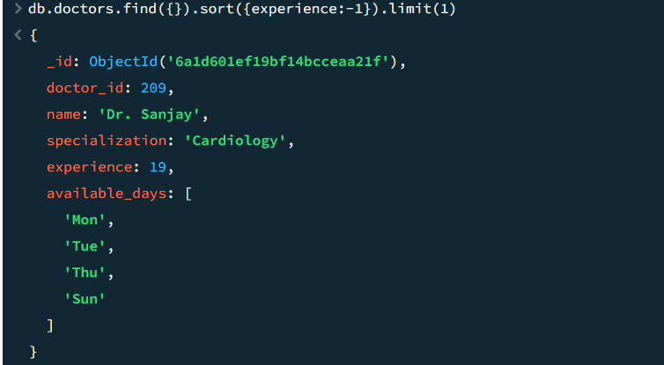

- Use conditional updates
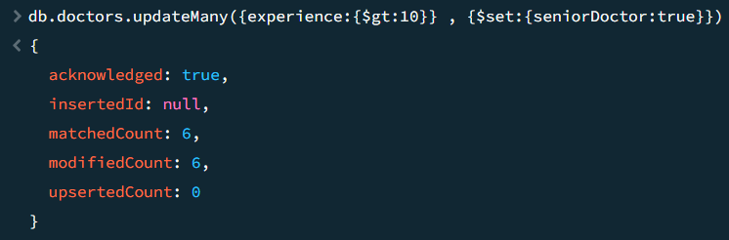

- Use updateMany()


Tasks
CREATE
- Create database food_delivery_db
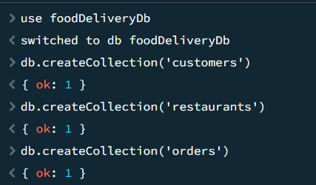
- Insert customers, restaurants, and orders
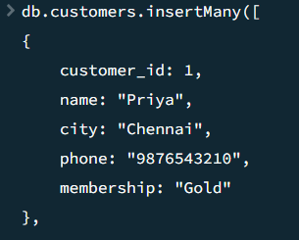

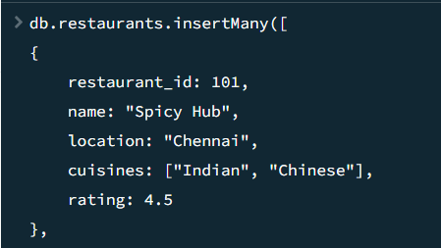

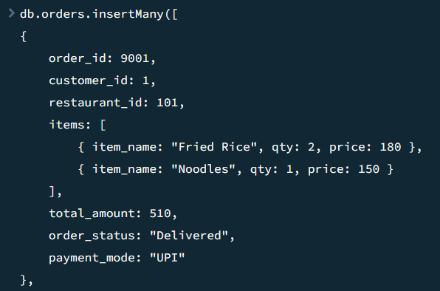
- Insert nested item arrays inside orders

- Insert bulk documents
Already Inserted above

READ
- Find gold membership customers
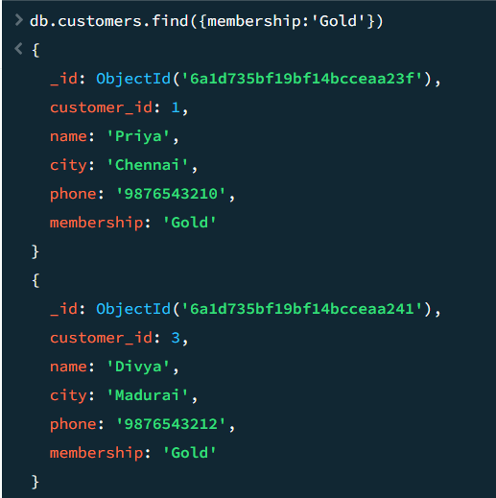

- Find restaurants with rating above 4
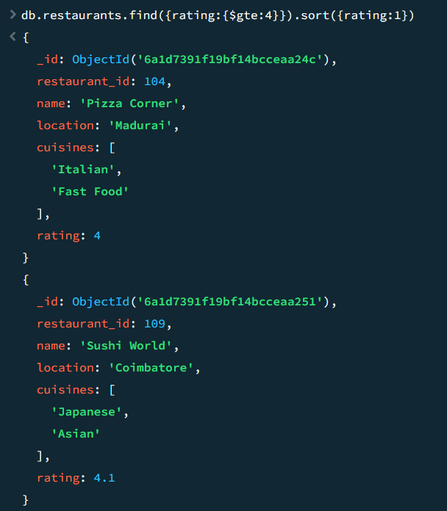
- Find orders paid through UPI
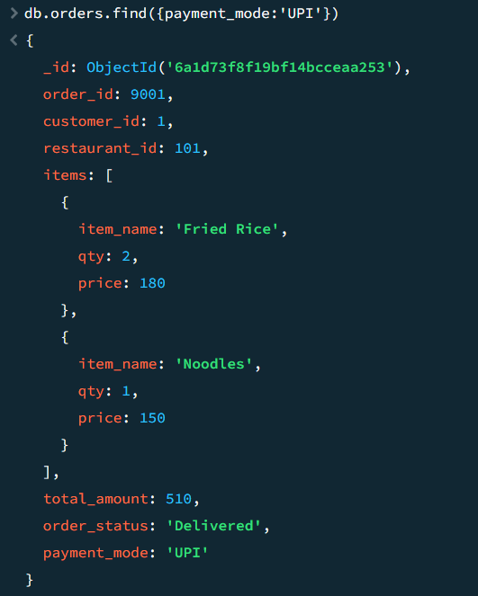

- Find delivered orders
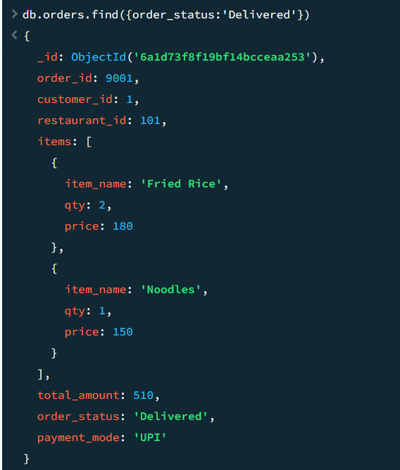
- Find orders with total amount above 1000
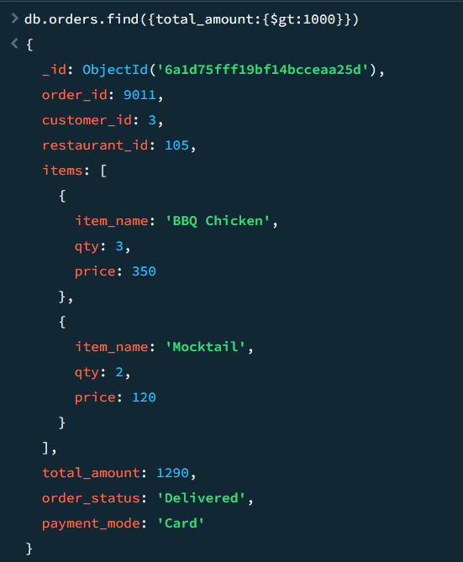

- Display restaurant cuisines
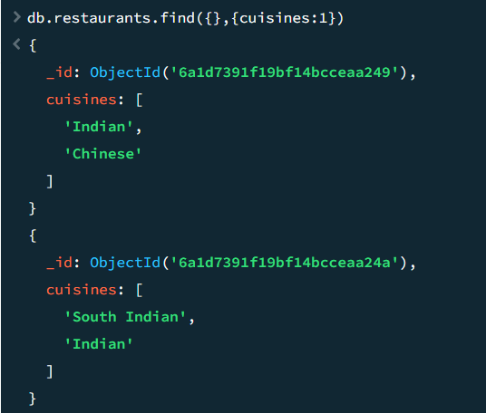
- Find customers from Chennai
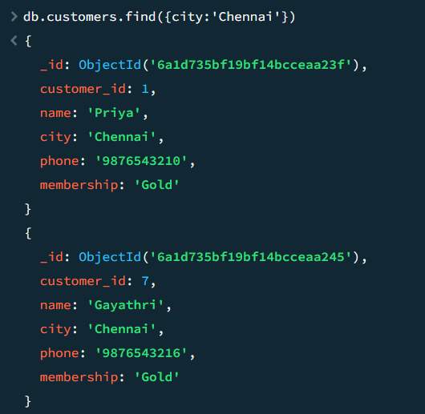

- Sort restaurants by rating descending
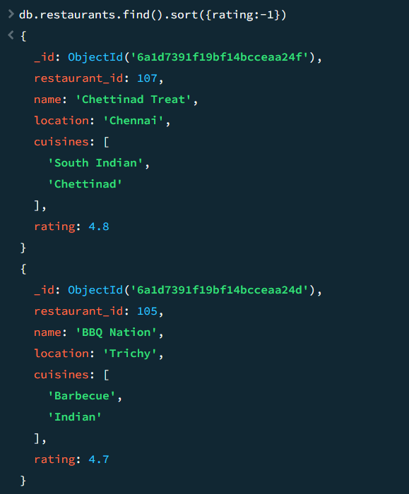

UPDATE
- Update customer membership
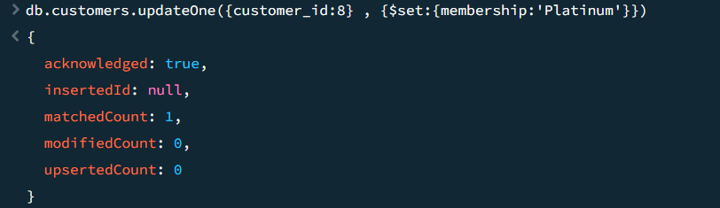

- Add cuisine to restaurant
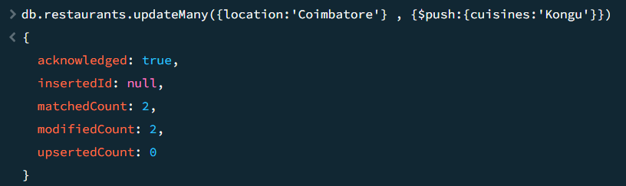
- Increase food item price
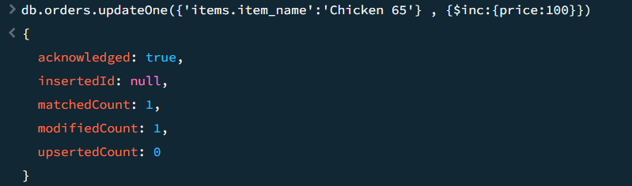
- Update order status
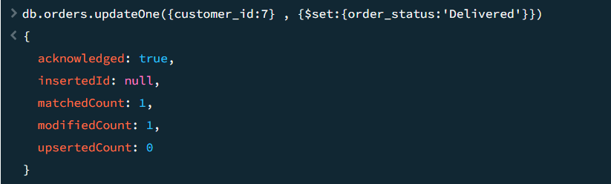
- Add item into existing order array
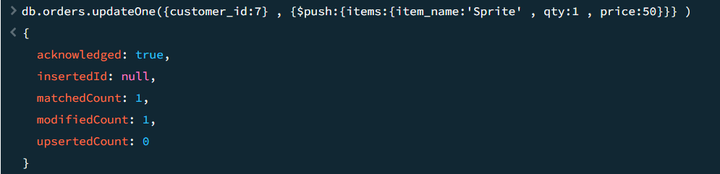

- Remove cancelled items from order
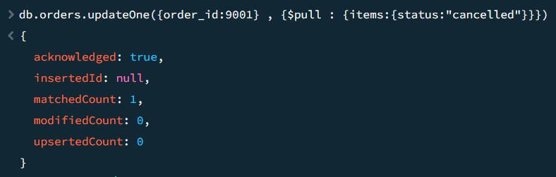
- Apply discount to total_amount
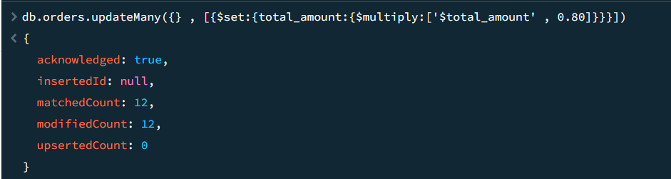

DELETE
- Delete cancelled orders
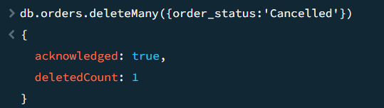
- Delete restaurants with low ratings
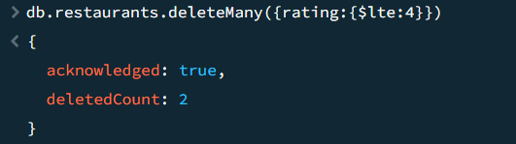

- Delete customers without orders
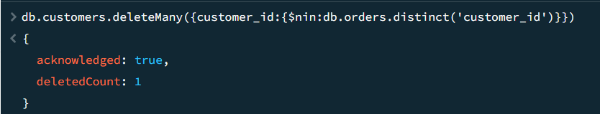

ADVANCED TASKS
- Use embedded documents efficiently
It is used in Restaurants collection
- Use arrays with CRUD operations
Creating Array
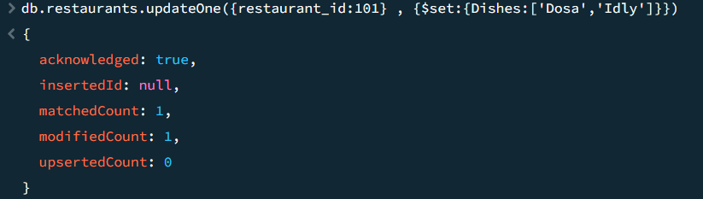

Push
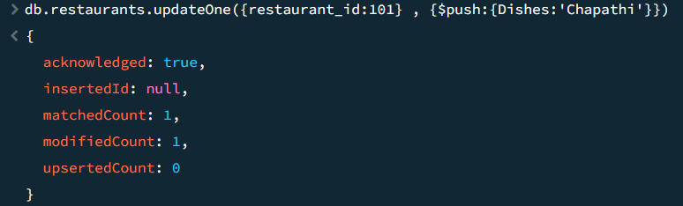

Pull
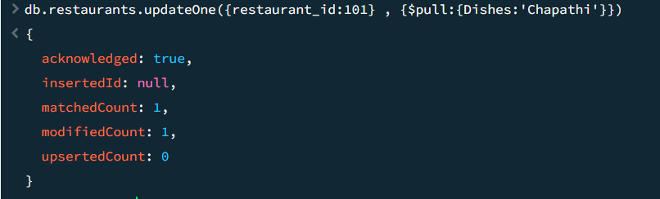

Pop
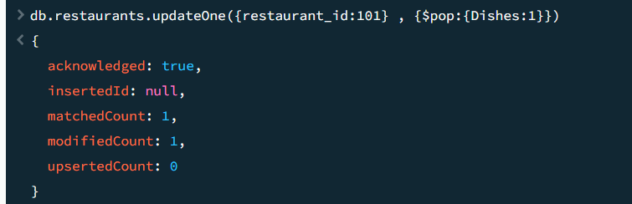

- Perform conditional updates


- Use projection operators
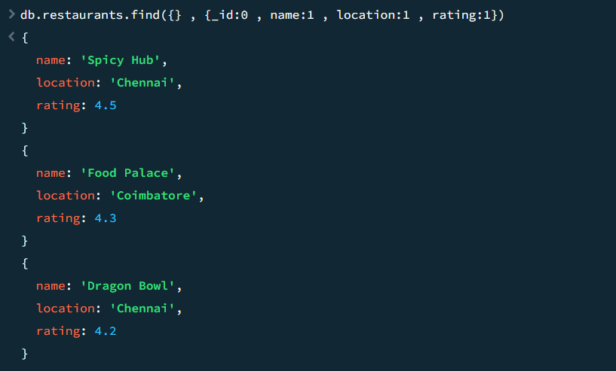
- Apply multi-document updates


- Use query operators:
  - $gt
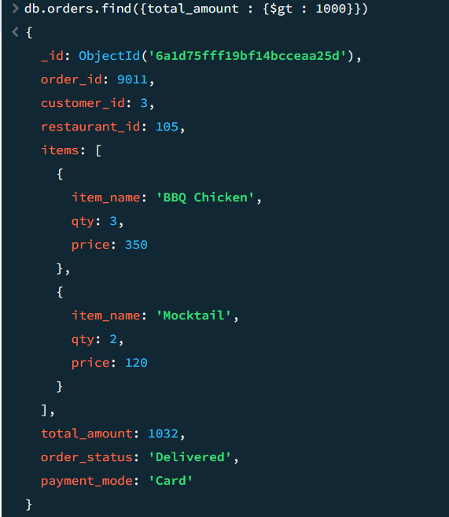

  - $lt
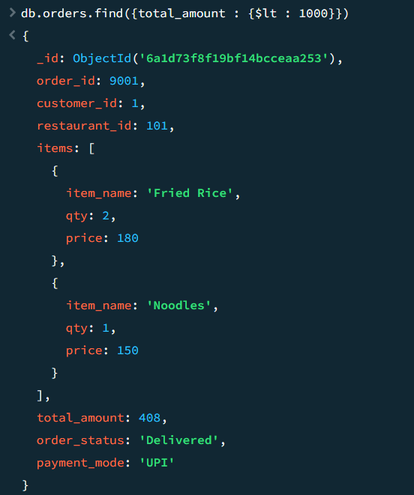

  - $in
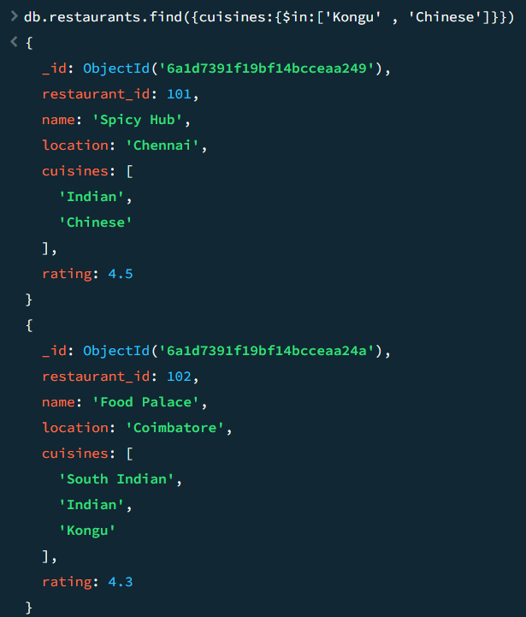
  - $and
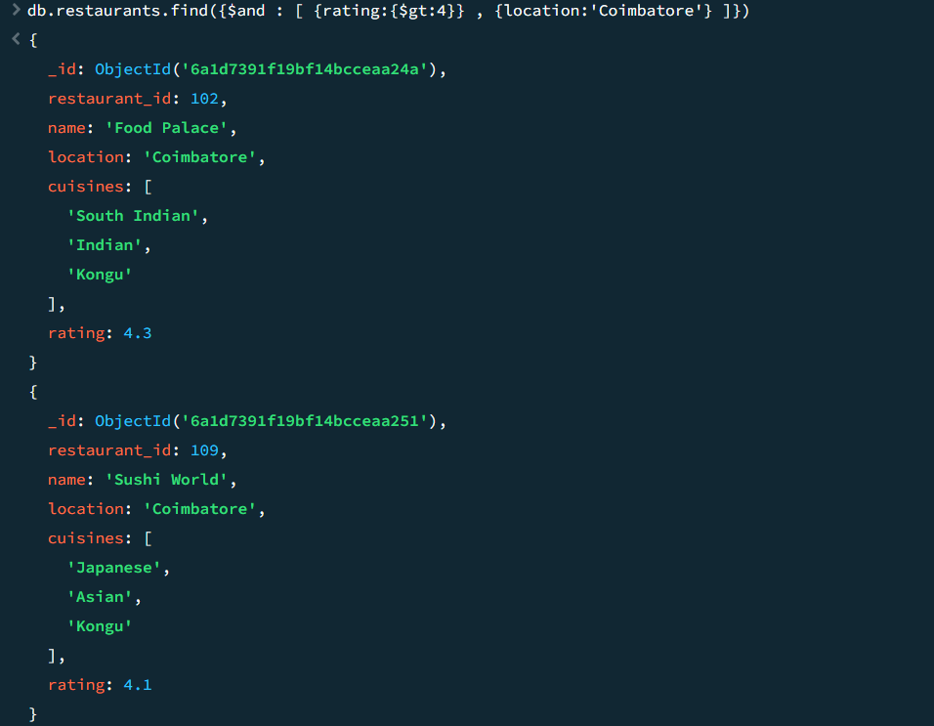

  - $or
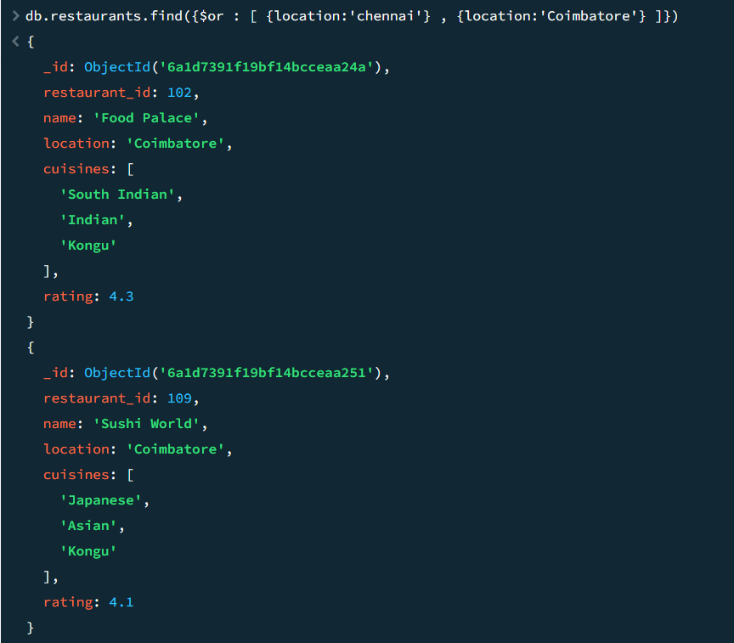

  - $elemMatch
